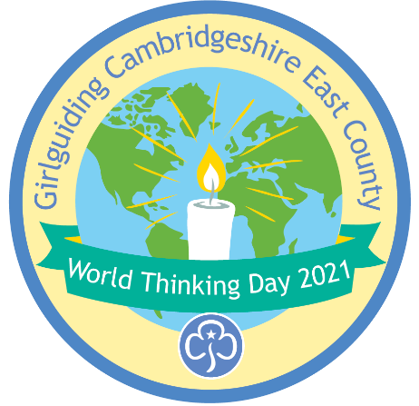
Cambs East World Thinking Day 2021 - badge order form

Unit

No of badges …………………… at £1 each £ ………

Postage 2nd class letter post as follows:

for 1-10 badges £ 1.00
for 11-50 badges £ 1.50
Over 50 badges £ 2.00

Total cost of badges £ ……………..

Contact name and address:

Please make cheques payable to “Cambs East Guides”
BACS transfer to Acc. No 00149798, sort code 309156
Send your order to:

Cambs East World Thinking Day badges 2021
Girlguiding Cambridgeshire East
3 Quy Court
Colliers Lane
Stow-Cum-Quy
Cambridge
CB25 9AU

Email: office@cambseastguides.org.uk

