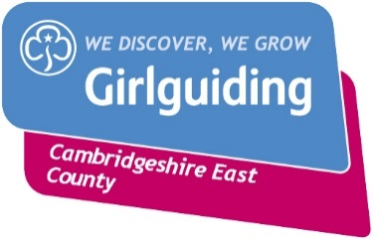
Gold Award Record and Badge Request Form
Recipient Name: |  | Membership number:

Completion of Gold Award
PART 1
Promise Date:
PART 2 (please include the name of the badges received and the dates they were awarded)
Theme (Skills builder and Unit Meeting Activities) | Date | Interest Badges | Date
Know Myself |  | 1.
Express Myself |  | 2
Be Well |  | 3.
Have Adventures |  | 4.
Take Action |  | 5.
Skills for My Future |  | 6.
PART 3
Gold Award Challenge | Date:

Gold badges and certificates required (please tick all that apply)

 | Metal (£2.05) |  | Woven (£1.00) |  | Certificate (£0.70)

Completed by:

Leader Name:
GO number
Unit & Section:
Email:
Telephone:

How to use this Form
- Use Page 1 for each girl in your unit who has achieved her Gold Award.

- Complete one copy of Page 2.

- Send copies of both pages to:

- County Office, 3 Quy Court, Stow-cum-Quy, Cambridge, CB25 9AU or email to office@cambseastguidesorg.uk

- Your badges and certificates will be sent to you with an invoice

- Please bear in mind that we only keep a small number of these in stock and you may have to wait until more are ordered in.

Information provided on this form will be processed by Girlguiding Cambs East in accordance with the Data Protection Act 1998 and General Data Protection Regulations. The data you provide will only be used for processing your badge application. The information will not be shared with other organisations.

For office use only: | Request form received | Payment received | Badge sent

